**1) USE CASES OF A FILE TRANSFER APP**

1. Transferring Files
2. Receiving Files
3. Getting devices IP Address
4. Setting Destination Directory
5. Establish a Secure Connection

* The FileTransferApp class contains methods for transferring files, getting connected devices, getting device IP addresses, and setting the destination directory. The Device class represents a device on the local network, and contains information about the device name and IP address. The SecureConnection class handles establishing a secure connection between devices before initiating a file transfer.
* The FileTransferApp class has a method transferFiles that takes in an array of File objects to transfer, a Device object representing the destination device, and boolean flags for encryption and authentication. It returns a boolean indicating whether the transfer was successful or not.
* The FileTransferApp class also has methods getConnectedDevices and getDeviceIPAddress for getting a list of connected devices and the IP address of a specific device, respectively. The setDestinationDirectory method allows the user to change the destination directory for received files.
* The SecureConnection class has a method establishConnection that takes in two Device objects representing the source and destination devices, and returns a boolean indicating whether the connection was successfully established or not.

**2) CLASS DIAGRAM**

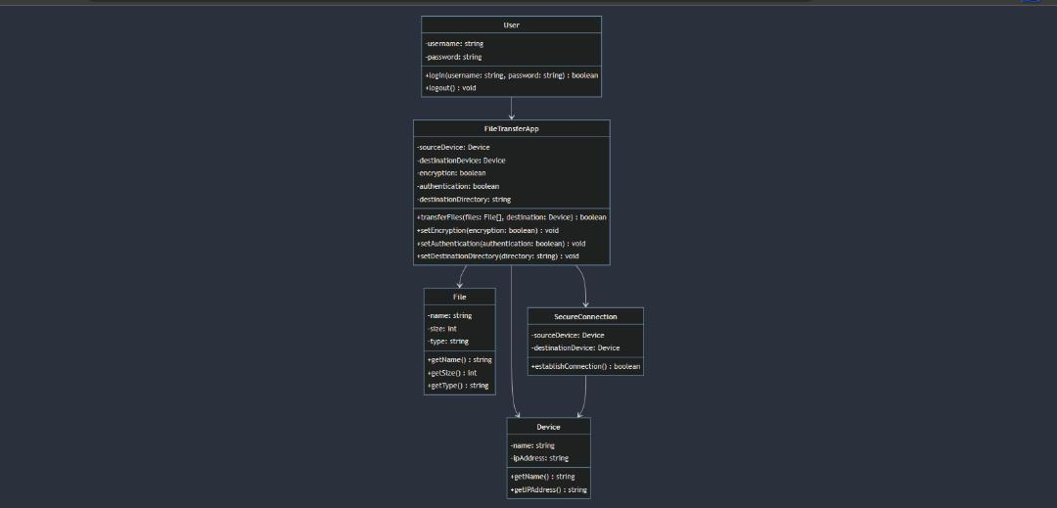

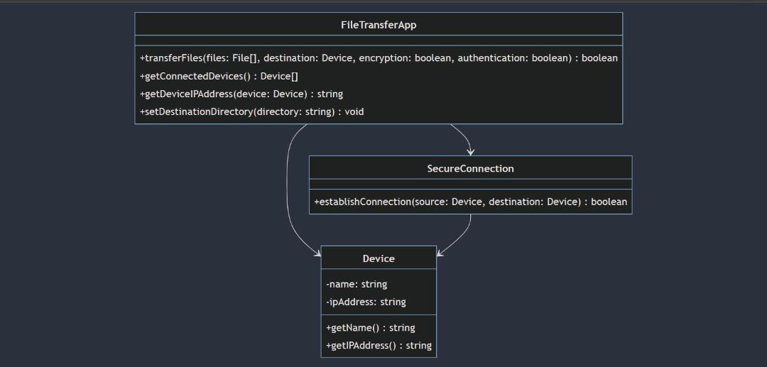

**SEQUENCE DIAGRAM**

This sequence diagram shows the interactions between the user, the FileTransferApp, the source device, and the destination device during a file transfer.

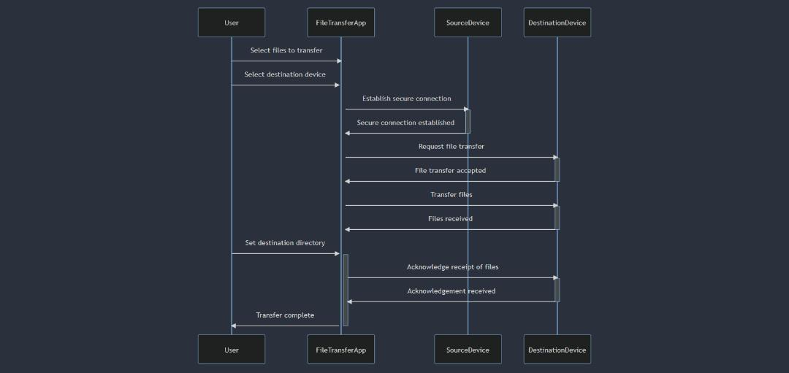

The diagram begins with the user selecting files to transfer and the destination device. The FileTransferApp then establishes a secure connection with the source device and requests the file transfer with the destination device. Once the transfer is accepted, the FileTransferApp transfers the files to the destination device. The user can then set the destination directory for the received files. The FileTransferApp acknowledges the receipt of the files to the destination device, and the transfer is complete.